Neural Representation of Graded TENS versus Vibrational Stimulation

- Purpose
Compare neural representation (EEG) of TENS vs. vibrational stimulation in able-bodied subjects

- Interested Questions
Main
- Is there a properly localized perception for TENS and for vibrational stimulation using EEG?
- Is the EEG signal under different modalities of stimulation different?
Other
- Does vibrational stimulation at the wrist elicit sensations in the hand?
- Location and perceived sensation in the hand for TENS and vibration

- Experimental Procedure
The experimental procedure is broken into three parts: 1) sensory mapping, 2) psychophysical experiments, and 3) EEG recording. General stimulation site is volar wrist of the subject’s non-dominant hand. The wrist was chosen because studies have used this stimulation site for both electrotactile and vibrotactile stimulations [1]. In general, stimulation sites and parameters for vibration are guided by those for TENS.
- Determine Stimulation Site
- TENS Sensory Mapping
The ground electrode (disposable Ag-Ag/Cl electrode) is placed at the radial side of the subject’s wrist. Perform sensory mapping using a 1-mm beryllium copper (BeCu) probe connected to a current stimulator (DS3, Digitimer Ltd.) [2], [3]. An amplitude (PA) of 0.5 mA, frequency (PF) of 10 Hz, and pulse width (PW) of 1 to 5 ms are used. As the experimenter uses the probe to explore the volar wrist area of the subject, the subject reports the stimulation site that elicits sensation in the hand. The location of elicited sensation is marked on a hand outline sheet. The stimulation site is marked and the parameters (amplitude, frequency, pulse width) are noted.
- Vibration
A DC eccentric rotating mass (ERM) vibration motor is used to provided vibrational stimulation. Stimulation site for vibration is the same as the marked location for TENS. The vibration motor rotates at a speed of 13000 rpm. Since the motor is driven by PWM of Arduino, the frequency of the specific digital pin used (D6) is 980 Hz. Details of vibration stimulation parameters can be found in Appendix 1.

- Psychophysics
Psychophysical experiments are performed to determine parameters such that the levels of stimulation intensity for both modalities are comparable. The goal of the following experiments is to find PF and PW for a continuous sensation at detection threshold.
- Frequency Discrimination
Threshold for a continuous sensation is the frequency where the probability of feeling a continuous sensation is 0.5 [2].
- TENS – Holding PA and PW at the values found in sensory mapping, frequency is modulated between 2 – 50 Hz. Every stimulation pattern was randomized and presented at least 5 times for each experiment. The subject is given a visual cue when the stimulation is on, and he/she verbally indicates whether the stimulation discrete or continuous. Threshold frequency is found by fitting the data to a sigmoid.
- Vibration – Holding PW at 50% duty cycle and carrier duty cycle of 100% [4]. Subsequent steps are similar to that of TENS.
- Detection Threshold
Detection threshold is the PW where the probability of feeling the stimulation is 0.5 [2]. For both TENS and vibration, PF is hold at the threshold for frequency discrimination. PW for TENS varies from 0 – 5 ms, and that for vibration varies from 0 – 20 ms. Similar to frequency discrimination, the subject is given a visual cue when the stimulation is on, and he/she verbally indicates whether the stimulation is felt.

Figures A3-1 and A3-2 in Appendix 3 show sample threshold plots for a preliminary psychophysical experiment following this protocol.

- EEG recording
The EEG data is collected through 64 channels at 500 Hz using a SynAmp2 system (Compumedics Neuroscan).
- Preparation
After cap placement, inject conductive gel into each electrode and check impedance simultaneously, to ensure impedance is $≤15 kΩ$.
- Baseline Recording
Record 2 trials of up to 1 min of EEG activity with no sensory stimuli presented to the subject.
- Stimulation and Recording
From psychophysics, one set of PF, PW, and PA is obtained for each stimulation modality. For EEG recording, trial 1 is TENS stimulation and trial 2 vibration. For each trial, three conditions are set in order for graded stimulation. Across three conditions, PF and PA are the same. PW is set as 100%, 150%, and 200% of the detection threshold.
For each trial, each condition is presented for 2 seconds at a time with a 15 ± 25% jitter second delay before the next presentation. Each condition is repeated 10 times per trial. An event trigger (“255”) is recorded in the EEG data as a separate trigger channel every time the stimulation is presented to the subject.

Potential Experiential Questionnaire:
+ Sensations felt, circle all that apply: vibrating, pain, tingling, hot, cold, electric
+ Intensity of each sensation: 1-10, 10 being strongest possible
+ Where do you feel it?
+ Have you ever had the same overall sensation “experience” in your every-day life? Yes/No
+ Would you describe this feeling as natural? Yes/No

At the end of each 2-second-stimulus, ask the subject the following questions:
- What kind of sensation do you feel? Vibration, pain, electrical tingling, hot, cold, other (specify)

References
[1] B. Stephens-Fripp, G. Alici, and R. Mutlu, “A Review of Non-Invasive Sensory Feedback Methods for Transradial Prosthetic Hands,” IEEE Access, vol. 6, pp. 6878–6899, 2018.
[2] L. Osborn et al., “Targeted transcutaneous electrical nerve stimulation for phantom limb sensory feedback,” in 2017 IEEE Biomedical Circuits and Systems Conference (BioCAS), 2017, pp. 1–4.
[3] L. E. Osborn et al., “Prosthesis with neuromorphic multilayered e-dermis perceives touch and pain,” Sci. Robot., vol. 3, no. 19, p. eaat3818, Jun. 2018.
[4] T. Rosenbaum-Chou, W. Daly, R. Austin, P. Chaubey, and D. A. Boone, “Development and Real World Use of a Vibratory Haptic Feedback System for Upper-Limb Prosthetic Users,” J. Prosthet. Orthot., vol. 28, no. 4, pp. 136–144, Oct. 2016.

Appendices
Appendix 1. Definitions of vibrational stimulation parameters

Two types of frequency are involved with regard to the vibration motor. The first is the carrier frequency, which can be viewed as the frequency that the motor is vibrating at, given a constant voltage supply [4]. This frequency and intensity of the vibration for ERM motors are changed by the amount of voltage used to drive the motor. In this case, it is the duty cycle of the carrier frequency (i.e. value used for Arduino AnalogWrite()).
The second frequency is the pulse frequency (PF), which is the frequency at which the motor is turned ON and OFF. This is the frequency modulated in TENS. In the experiment, varying PF and PW changes this pulse frequency and duty cycle. The pulse is a monophasic square wave.
Figure A1 is an example illustration of the two types of frequency. The carrier frequency is related to continuous vibration of the motor. The pulse frequency modulates ON and OFF of vibration.
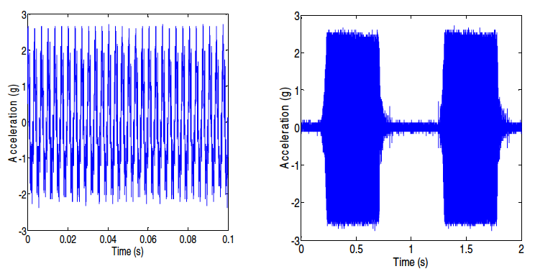
Figure A1. (Left) Vibration (carrier) frequency, modulated by voltage input. (Right) Pulse frequency. [1]

Appendix 2. Summary of previous vibrational stimulation studies on stim device, param, site

The following table reports previous studies on vibration stimulation.
Reference | Device | Stimulation Parameter | Stimulation Site | Note
Chen et al. 2008 [2] | N/A – only mentioned resonant frequency of 150 Hz | Duration 500 ms | Dorsal and volar wrist | Previous work suggested that tactor localization performance enhanced at anchor points such as wrist, elbow, shoulder.
Yao et al. 2013 [3] | Linear Resonant Actuator (LRA) | 175 Hz carrier frequency modulated with 27 Hz | Both left and right wrists | Study recorded EEG and investigated motor imagery with and without stimulation.
Chung et al. 2013 [4] | Customized MRI compatible device | Frequency 20 – 200 Hz | Index finger | Study used fMRI to investigate how somatosensory cortical activity changed with vibrotactile stimulation frequency.
Chaubey et al. 2014 [5] | C2 Tactor | Carrier frequency 250 Hz, duty cycle 50% | Bicep | Vibrational feedback improved grasping force error. Study noted that the average desensitization time was 66 seconds.
Rosenbaum-Chou et al. 2016 [6] | ERM | Change in pulse rate frequency, duty cycle, carrier frequency duty cycle | Bicep
Dosen et al. 2016 [7] | Brushless DC motor spinning a weight | Varying frequency 20 – 230 Hz, 20 – 80% of maximum amplitude | Forearm | Psychophysics results show that subjects had higher sensitivity to change in amplitude than in frequency
Li et al. 2016 [8] | ERM | Stimulation duration ranged from 50 – 500 ms | Dorsal side of each finger | Study developed a glove used on the intact hand of amputee subjects to display tactile feedback of the prosthetic hand.
Fontana et al. 2018 [9] | Coin vibrator (did not specify ERM or LRA) | Duration 1s, frequency 225 Hz, combinations of 3 motors turning on/off | Bicep | Study investigated able-bodied subjects’ ability to discriminate different stimulation sites and patterns.
Stephen-Fripp et al. 2018 [10] | LRA (9 in total) | PW: 200 ms, interstimulus onset interval 180 ms | Underside of arm | Study used overlapped vibration patterns to create movement sensation.
Chen et al. 2019 [11] | LRA | 175 Hz carrier frequency modulated with 27 Hz,  duration 5 s | Both left and right wrists | Recorded EEG show aging affected alpha and beta band power in somatosensory cortex under stimulation.

Appendix 3. Sample psychophysics

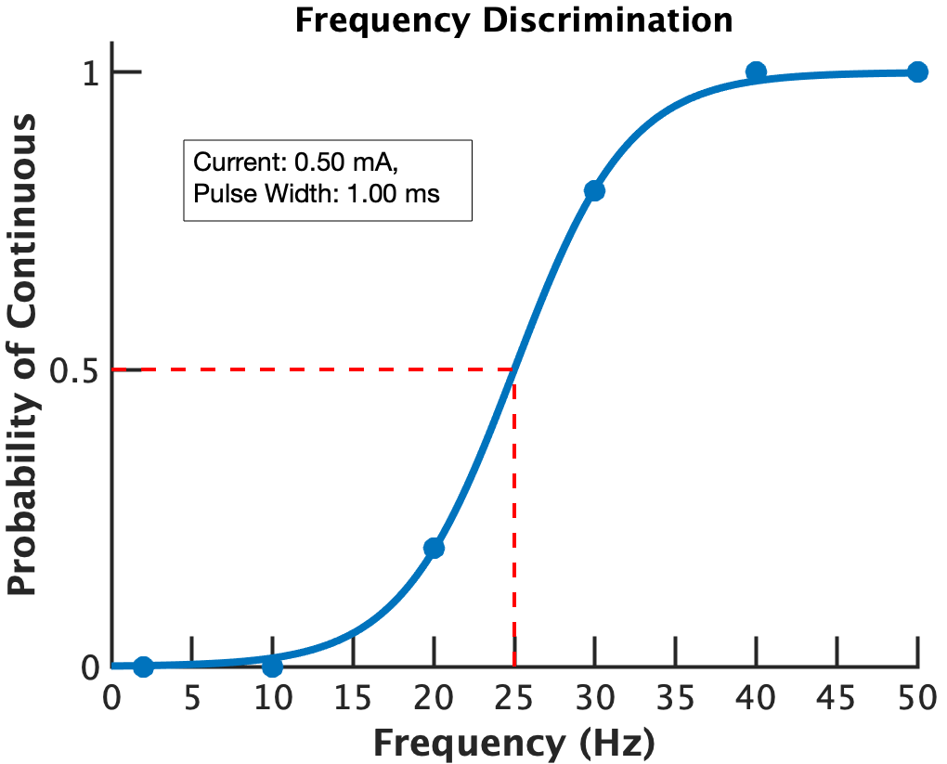

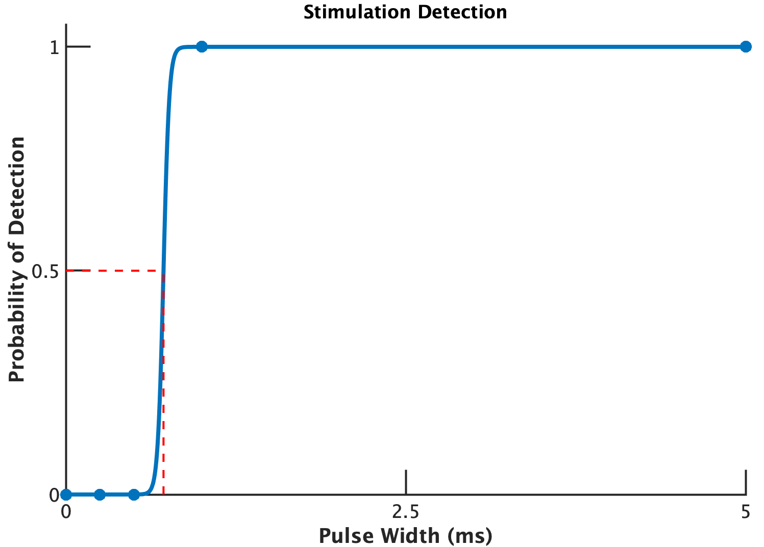
Figure A3-1. TENS Stimulation - Frequency threshold for continuous sensation (25 Hz) and PW threshold for detection sensitivity (0.7385 ms).

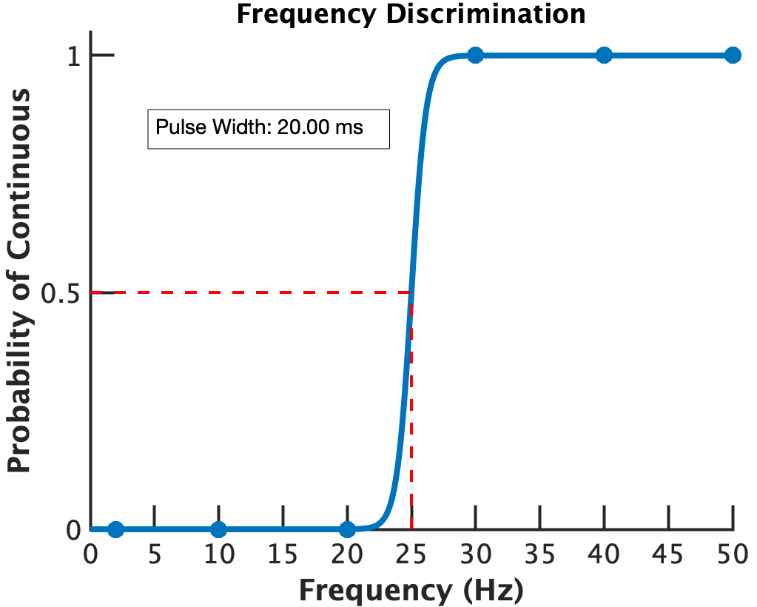

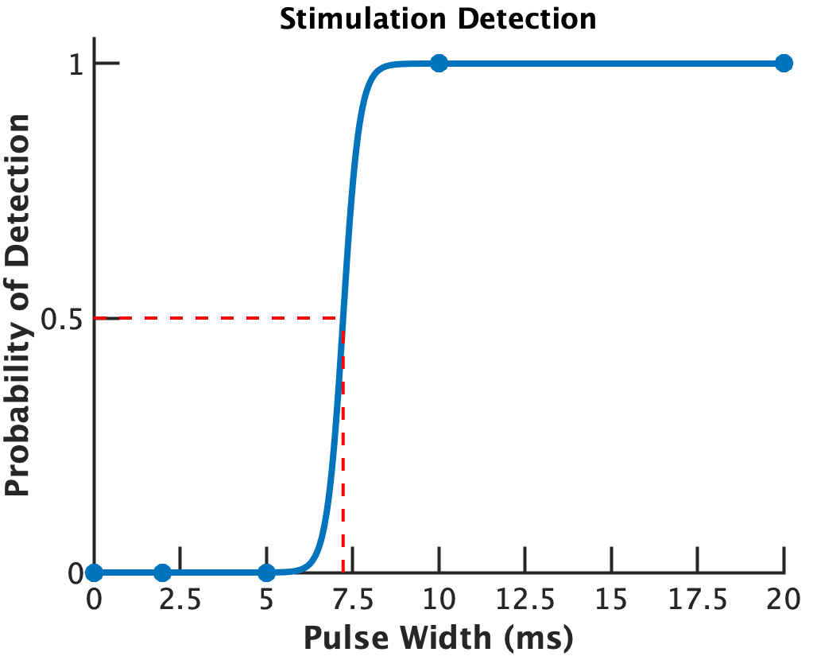
Figure A3-2. Vibration Stimulation - Frequency threshold for continuous sensation (25 Hz) and PW threshold for detection sensitivity (7.1996 ms).

References
[1] N. H. H. M. Hanif, N. N. N. Hashim, P. H. Chappell, N. M. White, and A. W. Cranny, “Tactile to vibrotactile sensory feedback interface for prosthethic hand users,” in 2016 IEEE EMBS Conference on Biomedical Engineering and Sciences (IECBES), 2016, pp. 326–330.
[2] H.-Y. Chen, J. Santos, M. Graves, K. Kim, and H. Z. Tan, “Tactor Localization at the Wrist,” in Haptics: Perception, Devices and Scenarios, vol. 5024, M. Ferre, Ed. Berlin, Heidelberg: Springer Berlin Heidelberg, 2008, pp. 209–218.
[3] Y. G. Chung et al., “Frequency-dependent patterns of somatosensory cortical responses to vibrotactile stimulation in humans: A fMRI study,” Brain Research, vol. 1504, pp. 47–57, Apr. 2013.
[4] L. Yao, J. Meng, D. Zhang, X. Sheng, and X. Zhu, “Selective Sensation Based Brain-Computer Interface via Mechanical Vibrotactile Stimulation,” PLoS One, vol. 8, no. 6, Jun. 2013.
[5] P. Chaubey, T. Rosenbaum-Chou, W. Daly, and D. Boone, “Closed-Loop Vibratory Haptic Feedback in Upper-Limb Prosthetic Users,” JPO: Journal of Prosthetics and Orthotics, vol. 26, no. 3, p. 120, Jul. 2014.
[6] T. Li, H. Huang, C. Antfolk, J. Justiz, and V. M. Koch, “Tactile display on the remaining hand for unilateral hand amputees,” Current Directions in Biomedical Engineering, vol. 2, no. 1, pp. 399–403, 2016.
[7] S. Dosen, A. Ninu, T. Yakimovich, H. Dietl, and D. Farina, “A Novel Method to Generate Amplitude-Frequency Modulated Vibrotactile Stimulation,” IEEE Transactions on Haptics, vol. 9, no. 1, pp. 3–12, Jan. 2016.
[8] T. Rosenbaum-Chou, W. Daly, R. Austin, P. Chaubey, and D. A. Boone, “Development and Real World Use of a Vibratory Haptic Feedback System for Upper-Limb Prosthetic Users,” Journal of Prosthetics and Orthotics, vol. 28, no. 4, pp. 136–144, Oct. 2016.
[9] B. Stephens-Fripp, R. Mutlu, and G. Alici, “Using Vibration Motors to Create Tactile Apparent Movement for Transradial Prosthetic Sensory Feedback,” in 2018 7th IEEE International Conference on Biomedical Robotics and Biomechatronics (Biorob), 2018, pp. 213–218.
[10] J. M. Fontana, R. O’Brien, E. Laciar, L. S. Maglione, and L. Molisani, “Vibrotactile Stimulation in the Upper-Arm for Restoring Individual Finger Sensations in Hand Prosthesis,” J. Med. Biol. Eng., vol. 38, no. 5, pp. 782–789, Oct. 2018.
[11] M. L. Chen, D. Fu, J. Boger, and N. Jiang, “Age-Related Changes in Vibro-Tactile EEG Response and Its Implications in BCI Applications: A Comparison Between Older and Younger Populations,” IEEE Transactions on Neural Systems and Rehabilitation Engineering, vol. 27, no. 4, pp. 603–610, Apr. 2019.

+

https://www.sparkfun.com/products/8449
https://www.arduino.cc/reference/en/language/functions/analog-io/analogwrite/

